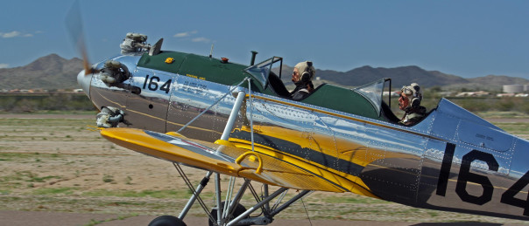
Name: ______________________________________
Address: ______________________________________
______________________________________
City, State, Zip ________________________________
Phone: home: __________________ Office: __________________ Cell: _________________
Email: ______________________________________
Is your membership: New Full Membership ($20.00)
Renewal Associate Membership (No Charge)
Name of Associate Member: __________________
FAA License: Private Commercial ATP Flight Instructor
Ratings: _____________________________________________
Do you own an Aircraft? Yes N-number: ___________ Make/Model: ____________
No
Are you building/restoring and aircraft? Yes Make/Model: ________________________
No
Are you a member of the National Antique Aircraft Assn (AAA)?
Yes: Member Number ____________ No
What other Aviation-Related groups are you a member of? __________________________________
__________________________________________________________________________________
Annual Dues: Member: $20.00 (per person) which Includes Associate Family member at no charge
Note: A full membership allows the member to vote and to serve as an officer or director. Each family must have at least one full member. All other family members may be associate members at no additional charge, but they will not be able to vote or hold office.
Please send your application and check to:
Classic Aircraft Association of Arizona
c/o Fred G. Borns
6 So. Stellar Parkway
Chandler, Arizona 85226

The Classic Aircraft Association of Arizona is a not-for-profit organization dedicated to the preservation and flying of antique and classic aircraft. It is not necessary to own and aircraft or to be a pilot to be a member

